Lab Experiment-12 by Shrikant Lal

Lab 12

1. Installing docker by using the following commands

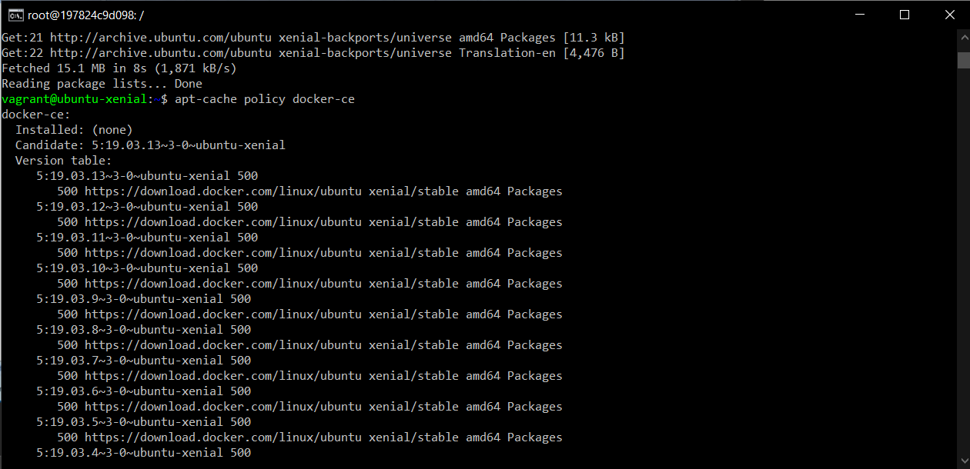

1. Running sudo apt-get install –y docker-ce to install docker

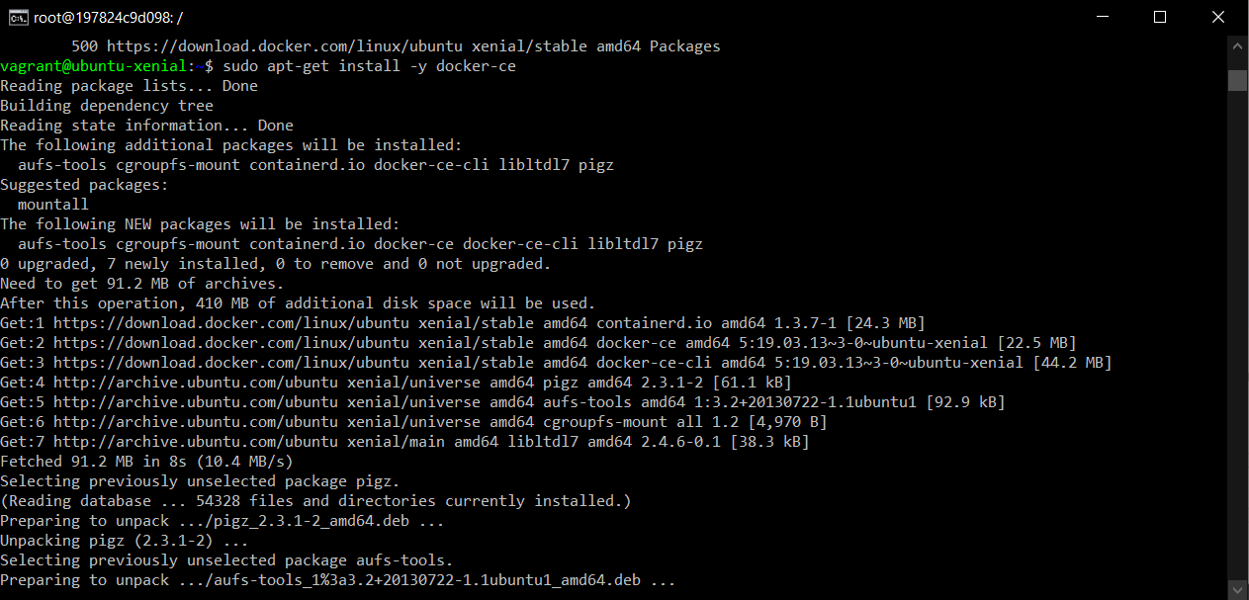

1. Docker installed creating the user for ubuntu image inside docker

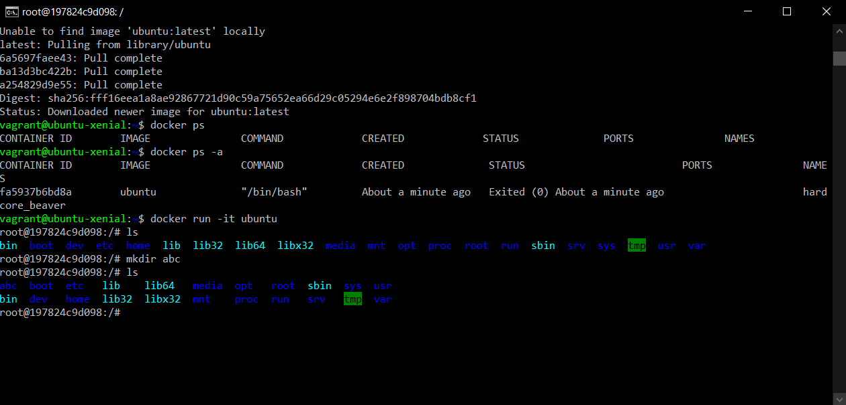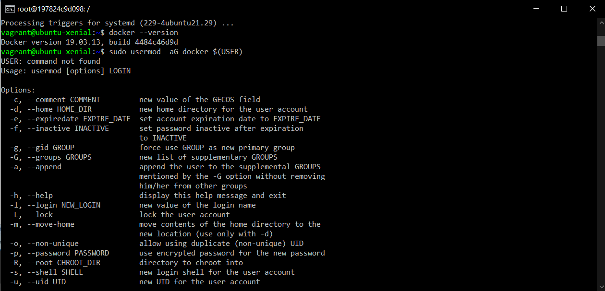

1. Switching to ubuntu in docker container by “docker run –it ubuntu” command

